INTRODUCTION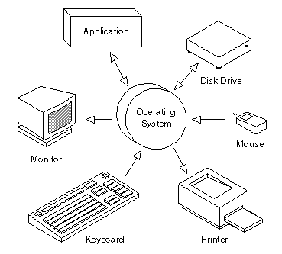 An operating system is a program that manages the computer hardware. It also provides a basis for application programs and acts as an intermediary between the computer user and the computer hardware. Every general purpose computer must have an operating system to run the other programs. Operating systems perform basic tasks, such as recognizing input from the keyboard, sending output to the display screen, keeping track of files and directories on the disk, and controlling peripheral devices such as disk drives and printers.

The O.S.s are varied in their character in accomplishing different tasks. Mainframe O.S.s are designed primarily to optimize utilization of hardware. Personal computer O.S.s support complex games, business applications and everything in between. O.S.s for handheld computers are designed to provide an environment in which a user can easily interface with the computer to execute programs. Thus, some operating systems are designed to be convenient, others to be efficient, and others some combination of the two.
For large systems, the operating system has even greater responsibilities and powers. It is like a traffic cop -- it makes sure that different program and users running at the same time do not interfere with each other. The operating system is also responsible for security, ensuring that unauthorized users do not access the system.

A computer system can be divided into four components:
- The hardware:-it includes the CPU, the memory, and the I/O devices. These provide the basic computing resources for the system.
- The application program:-such as word processors, spreadsheets, compilers and web browsers-define the ways in which these are used.
- The operating system:-controls and coordinates the use of hardware among the various application programs for the various users.

Services that operating system provides:
-- It provides process management.
- It creates or deletes the process.
- It suspends and resumes the process.
- It synchronizes the process.
- It helps in process communication.
- It handles the deadlock.
-- It does memory management.
- It keeps tracks of which part and by whom memory is used.
- It decides which job will be in the memory.
- Allocates and de-allocates the memory.
-- It provides file management.
- It creates and deletes file.
- It creates and deletes a directory.
- It manipulates the file.
- Keeps track of files in a disk.
- It keeps the back up files.
--It provides I/O management.
--It provides secondary storage management.
--It provides error detection.
--It provides resource allocation.

TYPES OF OPERATING SYSTEM

1. Batch Operating System
Users prepare a job and it consists of the data and programs. Many jobs are grouped together and run one after another. The jobs are kept in the disk and are selected by batch O.S. This is called job scheduling.

2. Multiprogramming Operating System
It means many jobs are kept in the main memory. Operating system picks up one job and when that job is finished or waiting for some I/O or doing some I/O operation, another job is picked for processing. So there is a switch over from one job to another.
This way the CPU is never idle but this O.S is more complex than the batch O.S since it has to do three things:
# Job scheduling
# Memory management
# CPU scheduling/processor management

The extensions of multiprogramming operating systems are:
- Time sharing
- Multiprocessing
- Real time

Time Sharing
CPU executes multiple jobs by switching among them and it is done so frequently that the user can communicate with computer directly during the execution time.

Multiprocessing
This is also known as parallel processing system and also tightly coupled system.
>> It provides increased throughput i.e. maximum number of jobs executed per unit time.
>>The increased number of processor does more work in less time.
>>It is also economic since it saves money than used in multiple single processor system as the CPUs in multiprocessor system share the same peripherals (disks, I/O, secondary storage etc.).
>>Increased reliability: if the functions are distributed among the CPUs and if one CPU fails then the job is done by the other CPU instead of a compete halt. This is called graceful degradation (the ability to continue providing service proportional to the level of surviving hardware). Some systems go beyond the graceful degradation and are called fault tolerant, because they can suffer a failure of any single component and still continue operation.

Multiprocessing systems are of two types:
Symmetric: The processor runs independently and has a copy of the O.S. They can communicate with each other.

Anti symmetric: There is a master who controls the other processors (slave ones).

Distributed Operating System
- Each processor has its own memory.
- They communicate with each other through various communication lines.
- This is also called loosely coupled system.

Network Operating System
- It gives the file sharing across the network and allows different processors on different computers to exchange messages.

Real Time
Responds to input instantly. As soon as the data comes it will be processed and the events will be executed. General purpose O.Ss, such as DOS and UNIX are not real time.

PROCESS
When a job is admitted to the system a corresponding process is created and it is inserted in the back of the ready list. It gradually moves to the head of the list. When it reaches the head and if the CPU is available then the process is given with the CPU by the dispatcher, this transition is called ready-to-running transition.

To prevent some process from monopolizing the system knowingly or unknowingly, O.S. sets a hardware clock to allow the user to run the program for a specific interval of time called quantum.
If the process doesn’t release the CPU voluntarily before the interval expires, the clock generates an interrupt calling the operating system to regain control. The O.S. sends this process back to the ready list and the next process will get the CPU.
If the running process initiate an I/O operation before its quantum expires then the process releases the CPU and blocks itself.
If the process is completed within the quantum then it is terminated.
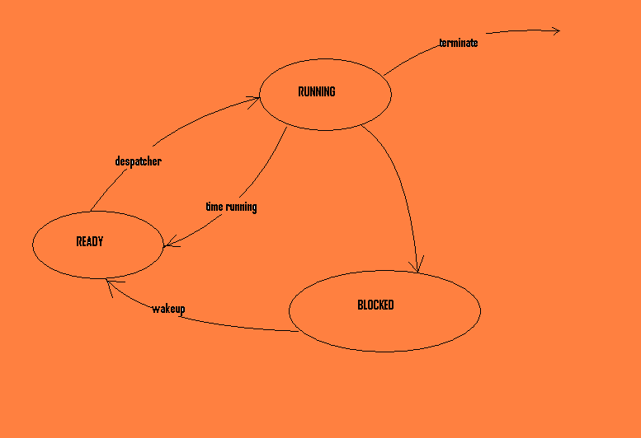
PCB (Process Control Block)
Each process is represented in O.S. by PCB. It contains many information about the process such as:
- It contains the state of the process.
- It contains process priority.
- It contains the pointer to locate the process in the memory.
- It contains the pointers to the allocated resources and the register save area.
The PCB contains information which differs from process to process.
This allows the O.S. to locate all key information of the process. When the O.S. switches the attention of the CPU among the process, that time only it uses the save area in the PCB to hold the information it needs to restart each process when the process next gets the CPU.

What an operating system does on a process?
An operating system
- Creates a process
- Destroys a process
- Suspends a process
- Resumes a process
- Changes the process priority
- Blocks a process
- Wakes up a process
- Dispatches a process

While creating a process, the O.S. will
- Name the process
- Install it in the system
- Determine its initial priority
- Create the PCB and allocates the initial resources to the process.
A process itself may create another process. The creating process is called as the parent process and the created process is called the child process.

Destroying a process means removing it from the system. In this action the O.S. erases the PCB and returns the resources to the system.

Suspended process: when the process is suspended it can’t proceed until another process resumes its place. The process is suspended briefly during the peak loading system. System removes some process temporarily during the peak time. For a long term suspension, resources should be freed depending upon the importance of the resources and the resources are removed from the main memory and sent to the secondary memory.

Resuming a process means to restart a process from the point where it was suspended.

Process termination: There are two commands to execute this: exit and abort.
When the process finishes and its last command is ‘exit’, then the process will be removed from the system. All its resources will be de-allocated.
When the process gives a command ‘abort’, it gets terminated and with its termination all its child process also gets terminated. This situation arises when the sub processes have used some of the resources more or when the job of the sub processes is not needed any more and another situation is that the parent process is terminated and the O.S. doesn’t allow the sub processes to continue.
When parent process terminates and the child process has to terminate then this type of termination is called cascading termination.

Interrupt processing:
Interrupt is an event that alters the sequence in which the processor executes the instruction and it is generated by the hardware. When the interrupt is given:
- O.S. gains control.
- It saves the state of the interrupted process in the PCB.
- O.S. will analyze the interrupt and pass the control to the appropriate routine to handle the interrupt.
Interruption may be initiated by the process or may be caused by some events which may or may not be related to the process.

Types of interruption
There are six types of interruption:

1. SVC (Supervisor call)
This is initiated by the running process for asking for I/O device or for asking for more memory. Operating system will analyze the privilege of the process and may or may not allow the request.
2. I/O interrupt
- This is initiated by the I/O device.
- This is caused when the I/O operation is complete or if there are any type of error.
3. External interrupt
- This interrupt is given by the clock.
-this interruption may be due to:
  - Expiry of quantum.
  - If the interrupt key is pressed by the operator.
  - May be initiated by a processor.
4. Restart
When the operator presses the restart button.
5. Program check error
This is caused by various types of errors by the running process.
6. Machine check interrupt
This interruption occurs when there is any type of malfunction of the hardware.

For each interrupt there are six separate interrupt handlers. Operating system analyzes these interrupts and sends the control to the respective interrupt handlers. This type of technique is known as context switching (it is the switching of the CPU to another process after saving the state/ context of the current running process and restoring the state of the next process).
A trap (or an exception) is a software-generated interrupt caused either by an error (for example, division by zero or invalid memory access) or by a specific request from a user program that an operating system service be performed.

CPU Scheduling
Meaning: the technique of deciding as when and which process will access the CPU is known as CPU-scheduling or processor scheduling.
Time-sharing and multiprogramming require several jobs to be kept simultaneously in the memory. Since, in general, main memory is too small to accommodate all jobs; the jobs are kept initially on the disk in the job pool. This pool consists of all processes residing on the disk awaiting allocation of main memory.

There are three levels of CPU scheduling:
- High level scheduling
- Intermediate level scheduling
- Low level scheduling

High level scheduling
It is also called job scheduling. If several jobs are ready to be brought into the memory, and if there is not enough room for all of them, then the system must choose among them. Making this decision is called job scheduling.

Intermediate level scheduling
When the operating system selects a job from the job pool, it loads that job into the memory for execution. Having several programs in the memory at the same time requires some form of memory management. In addition, if several jobs are ready to run at the same time, the system must choose among them that which job should get the CPU. This process is actually known as CPU scheduling.

Low level scheduling
At this level the process is dispatched to the CPU or vice versa.

Objective of the CPU
- It should be fair i.e. all the processes should be serviced equally. There shouldn’t be indefinite postponement of the jobs.
- It should maximize the through put. It should serve maximum number of processes per unit time.
- CPU scheduling should be predictable i.e. a given job should run in about the same amount of time and should have the same cost regardless of the load of the system.
- It should minimize the overhead. It should balance the resources i.e. all the resources should be busy all the time. Overhead: it is time gap between the end of one job and the start of the next job.
- It should enforce priority of the jobs.
- It should degrade gracefully under heavy load.

Turn around time:
This is time difference between the submission of the job and the completion of the job.
Waiting time:
It is the time to get the CPU.
Response time:
It is the amount of time taken by the CPU to start responding.

Scheduling criteria
Many criteria have been suggested for comparing CPU scheduling algorithms. The criteria include the following:
- CPU utilization the CPU should be made as busy as possible. Conceptually, CPU utilization can range from 0 to 100%. But in a real system, it should vary from 40% (for lightly loaded system) to 90% (for heavily loaded system).
- Throughput it is the number of processes that are completed per unit time. For long processes, this rate may be one process per hour; for short transactions, it may be 10 processes per second.
- Turnaround time from the point of view of a particular process, the important criterion is how to execute that process. The interval from the time of submission of a process to the time of completion is the turn around time. It is the sum of the periods spent waiting to get into memory, waiting in the ready queue, executing on the CPU, and doing I/O.
- Waiting time it is the sum of time spent waiting in the ready queue.
- Response time in an interactive system, turnaround time may not be the best criterion. Often, a process can produce some output fairly early and can continue computing new results while previous results are being output to the user. Thus, another measure is the time from the submission of a request until the first response is produced. This measure, called response time, is the time it takes to start responding, not the time to output the response.

The scheduling should also look at
  - Which processes are CPU bound.
  - Which processes are I/O bound.
  - Whether the processes are batch processes or interactive processes (which needs immediate response).
  - It should decide the priority.

The scheduling can be of two types:
- Preemptive
- Non- preemptive

Preemptive scheduling: in this type of scheduling the CPU can be taken away from the process. It is a bit complicated one.
Example: in real time environment, under priority consideration.
Non-preemptive scheduling: it is otherwise known as cooperative. In this type of scheduling once the CPU is given to the process then it can’t be taken away from it until it releases the CPU either by terminating or by switching to the waiting state. This scheduling is easy to implement. The disadvantage in this case is that the short jobs have to wait for execution beyond the long jobs.

Interval timer (interrupting clock)
When the process has the CPU (i.e. the process is running) then to prevent the user from monopolizing the CPU/system i.e. to prevent a user program from getting stuck in an infinite loop calling system services and never returning control to the operating system the O.S has the mechanism of taking away the CPU from the process. To accomplish this goal, the O.S uses an interval timer to generate an interrupt at some elapsed time and at that moment the CPU is taken away from the process. The CPU is then dispatched to the next process. The time period may be fixed (for example, 1/60 second) or variable (for example, from 1 millisecond to 1 second). A variable timer is generally implemented by a fixed-rate clock and a counter.
Before turning over control to the user, the operating system ensures that the timer is set to interrupt. If the timer interrupts, control transfers automatically to the operating system, which may treat the interrupt as a fatal error or may give the program more time.

Priority (in which order jobs will be processed)
- It may be assigned automatically by the system or it may be external.
- It can be bought/ purchased (sometimes the users pay higher premium to get better service).
- It can be static or may be dynamic. In static priority, the priority is not changed with change of situation, but in dynamic priority the priority is changed with change of situation i.e. initially priority will be given to a process then it is adjusted depending upon the situation.

Different types of scheduling
  - Deadline scheduling: certain jobs are scheduled to be completed within a specific time which is called deadline scheduling. These jobs may have high value if they are delivered in time and may be worthless if they are delivered after the deadline. At that time the user pay more for timely completion of the job.
  - CPU scheduling: This type of scheduling deals with the problem of deciding which of the processes in the ready queue is to be allocated the CPU. There are many different CPU scheduling algorithms. They are:
    - First come first served scheduling (FCFS) this is the simplest one. With this scheme, the process that requests the CPU first is allocated the CPU first. When a process enters the ready list, its PCB is linked onto the tail of the queue. When the CPU is free, it is allocated to the process at the head of the queue. The running process is then removed from the queue. This type of scheduling is non-preemptive one. There is no abnormal termination of the processes. The average waiting time under the FCFS policy, is however, often long. For example: consider the following set of processes that arrive at time 0.
Process Burst time
P1 24
P2 3
P3 3
If the processes arrive in the order P1, P2, and P3 and are served in FCFS order, we get the result as shown in the Gantt chart:
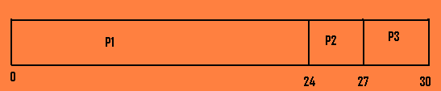
The waiting time is 0 milliseconds for process P1, 24 milliseconds for process P2 and 27 milliseconds for process P3. So the average waiting time is 17 milliseconds. If the processes arrive in the order P2, P3, P1, however, the results will be different, as shown below:
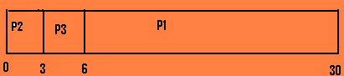

The average waiting time is now 3 milliseconds. Thus the average waiting time under an FCFS policy is generally not minimal and may vary substantially if the process’s CPU burst times vary greatly. This type of scheduling is non preemptive one. Once the CPU has been allocated to a process, that process keeps the CPU until it releases the CPU, either by terminating or by requesting I/O. It’s not good for time sharing systems.

- Shortest-Job-First scheduling (SJF) this algorithm associates with each process the length of the process’s next CPU burst. When CPU is available, it is assigned to the process that has the smallest next CPU burst. If the next CPU bursts of two processes are the same, FCFS scheduling is used to break the tie. In other words, waiting processes with a small estimated run time are first to be finished and successively the processes are undertaken. It is a non preemptive one.
As an example of SJF scheduling, let us consider the following set of processes, with the length of the CPU burst given in milliseconds:
Process Burst time Waiting time
P1 6 3
P2 8 16
P3 7 9
P4 3 0
Using SJF scheduling, we would schedule these processes according to the following Gantt chart:
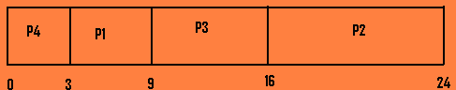
The average waiting time in this case is 7 milliseconds. By comparison, if we are using the FCFS scheduling scheme, the average waiting time would be 10.25 milliseconds. The SJF scheduling is provably optimal i.e. it gives the minimum average waiting time for a given set of processes.
Disadvantages with the SJF scheduling are:
- The real difficulty with the SJF algorithm is, knowing the length of the next CPU request.
- SJF scheduling is used frequently in long-term scheduling, but it can’t be implemented at the level of short-term CPU scheduling.
- It requires precise knowledge of the burst time. If it is not available then the estimated time has to be fixed by the users.

The SJF algorithm can be either preemptive or non-preemptive. The choice arises when a new process arrives at the ready queue while a previous process is still executing. The next CPU burst of the newly arrived process may be shorter than what is left of the currently executing process. A preemptive SJF algorithm will preempt the currently executing process, whereas a non preemptive SJF algorithm will allow the currently running process to finish its CPU burst. Preemptive SJF scheduling is sometimes called shortest-remaining-time-first scheduling.
As an example, let us consider the following four processes, with the length of the CPU burst given in milliseconds:
Process Arrival time Burst time
P1 0 8
P2 1 4
P3 2 9
P4 3 5
If the processes arrive at the ready queue at the times shown above and need the indicated burst times, then the resulting preemptive SJF schedule is as depicted in the following Gantt chart:
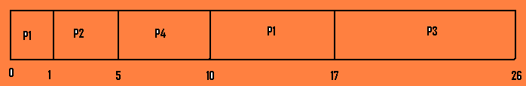
Process P1 is started at time 0, since it is the only process in the queue. Process P2 arrives at time 1. The remaining time for process P1 (7 milliseconds) is larger than the time required by process P2 (4 milliseconds), so process P1 is preempted, and process P2 is scheduled. The average waiting time for this example is ((10-1) + (1-1) + (17-2) + (5-3)) / 4= 6.5 milliseconds. Non preemptive SJF scheduling would result in an average waiting time of 7.75 milliseconds.
Some of the disadvantages of the shortest-remaining-time-first policy are:
- Higher overhead.
- It has to keep track of remaining time of the currently executing process so that it can handle the preemption.
- Arriving small processes will run immediately and longer job will have to wait even longer.

- Priority scheduling the SJF algorithm is a special case of the general priority scheduling algorithm. A priority is associated with each process, and the CPU is allocated to the process with the highest priority. Equal priority processes are scheduled in FCFS order. An SJF algorithm is simply a priority algorithm where the priority (p) is the inverse of the (predicted) next CPU burst. The larger the CPU burst, the lower the priority and vice versa. Priorities are generally indicated by some fixed range of numbers, such as 0 to 7 or 0 to 4095. The low numbers represent the high priority.
As an example let us consider the following set of processes, assumed to have arrived at time 0, in the order P1, P2,…., P5 with the length of the CPU burst given in milliseconds:
Process Burst time Priority Waiting time
P1 10 3 6
P2 1 1 0
P3 2 4 16
P4 1 5 18
P5 5 2 19
Using priority scheduling, we would schedule these processes according to the following Gantt chart:

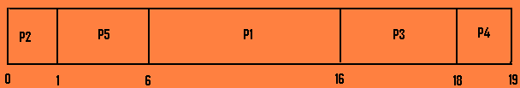
The average waiting time is 8.2 milliseconds.
Priorities can be defined either internally or externally. Internally defined priorities use some measurable quantity/ quantities to compute the priority of a process. For example, time limits, memory requirements, the number of open files and the ratio of average CPU burst have been used in computing priorities. External priorities are set by criteria outside the operating system, such as the importance of the process, the type and amount of funds being paid for computer use, the department sponsoring the work and other, often political, factors.
Priority scheduling can be either preemptive or non preemptive. When a process arrives at the ready queue, its priority is compared with the priority of the current running process. A preemptive priority scheduling algorithm will preempt the CPU if the priority of the newly arrived process is higher than the priority of the currently running process. A non preemptive priority scheduling algorithm will simply put the new process at the head of the ready queue.
A major problem in priority scheduling is that it results in indefinite blocking or starvation of some low priority processes. It can also leave some low priority processes waiting indefinitely. In a heavily loaded computer system, a steady stream of higher-priority processes can prevent a low priority process from getting the CPU.
A solution to the problem of indefinite blockage of low-priority processes is aging. Aging is a technique of gradually increasing the priority of the processes that wait in the system for a long time.

- Round Robin Scheduling The Round Robin (RR) scheduling algorithm is designed especially for time-sharing systems. It is similar to FCFS scheduling, but preemption is added between processes. The CPU scheduler goes around the ready queue, allocating the CPU to each process for a time interval of up to 1 time quantum (about 10 to 100 milliseconds).
To implement RR scheduling, we keep the ready queue as a FIFO queue of process. New processes are added to the tail of the ready queue. The CPU scheduler picks the first process from the ready queue, sets a timer to interrupt after 1 time quantum, and dispatches the process. One of two things will happen:
1. The process may have a CPU burst of less than 1 time quantum. In this case, the process itself will release the CPU voluntarily. The scheduler will then proceed to the next process in the ready queue.
2. If the running process has CPU burst more than 1 time quantum, then the timer will go off and will cause an interrupt to the operating system. A context switch will be executed, and the process will be put at the tail of the ready queue. The CPU scheduler will then select the next process in the ready queue.
In RR scheduling no process is given CPU for more than one time quantum in a row. When the quantum is very large in a system it becomes a normal FCFS type of scheduling. If the quantum is very small overhead should be large and there will be too much context switching.
The average waiting time under the RR policy is often long. For example: let us consider the following set of processes that arrive at time 0, with the length of the CPU burst given in milliseconds:
Process Burst time
P1 24
P2 3
P3 3
If the time quantum is taken as 4 milliseconds, then process P1 gets the first 4 milliseconds. Since it requires another 20 milliseconds, it is preempted after the first quantum, and the CPU is given to the next process in the queue, process P2. Since process P2 does not need 4 milliseconds, it quits before its time quantum expires. The CPU is then given to the next process, P3. Once each process has received 1 time quantum, the CPU is returned to process P1 for an additional quantum. The resulting Gantt chart is given as:

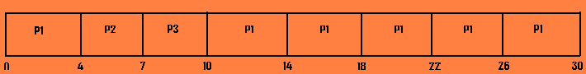
The average waiting time is 17/3=5.56 milliseconds.

- Multilevel Queue Scheduling In this type of scheduling the processes are classified into different groups. For example, a common division is made between foreground (interactive) processes and background (batch) processes. These types of processes have different response time requirements and so may have different scheduling needs. In addition the foreground processes may have priority (externally defined) over background processes.
A multilevel queue scheduling algorithm partitions the ready queue into several separate queues. The processes are permanently assigned to one queue, generally based on some property of the process, such as memory size, process priority or process type.
Each queue has its own scheduling algorithm. For example, separate queues might be used for foreground and background processes. The foreground queue might be scheduled by an RR algorithm, while the background queue is scheduled by an FCFS algorithm.
In addition, there must be scheduling among the queues, which is commonly implemented as fixed-priority preemptive scheduling. For example, the foreground queue may have absolute priority over the background queue.
Let us take into consideration a multilevel queue scheduling algorithm with five queues in order of priority as below:
      - system process
      - interactive process
      - interactive editing process
      - batch process
      - student process

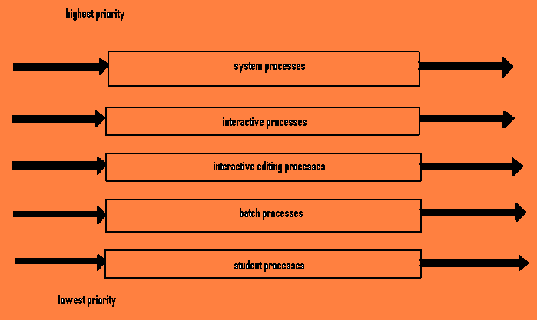
Multilevel queue scheduling
Each queue has absolute priority over lower priority queues. No process in the batch queue, for example, could run unless the queues for system processes, interactive processes and interactive editing processes were all empty. If an interactive editing process entered the ready queue while a batch process was running, the batch process would be preempted.
Another possibility is to time slice among the queues. Here, each queue gets a certain portion of the CPU time, which it can then schedule among its various processes.

- Multilevel Feedback-Queue Scheduling In multilevel queue scheduling algorithm processes are permanently assigned to a queue when they enter the system. If there are separate queues for foreground and background processes, the processes do not move from one queue to another, since processes do not change their foreground or background nature. So it may happen that the background processes may suffer from starvation. Multilevel queue scheduling has the advantage of low scheduling overhead, but it is not flexible.
The multilevel feedback-queue scheduling algorithm, in contrast, allows a process to move between queues. The idea is to separate processes according to the characteristics of their CPU bursts. If a process uses too much CPU time, it will be moved to a lower priority queue. This scheme leaves I/O bound and interactive processes in the higher priority queues. In addition, a process that waits too long in a lower priority queue may be moved to a higher priority queue. This form of aging prevents starvation.
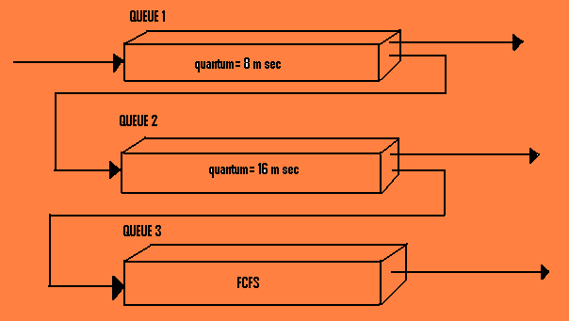
Multilevel feedback queues

Let us take into account the queues shown above. The scheduler first executes all processes in queue 1. Only when queue-1 is empty will it execute processes in queue-2. Similarly, processes in queue-3 will only be executed if queues 1 and 2 are empty. A process that arrives for queue-2 will preempt a process in queue-3. A process in queue-2 will in turn be preempted by a process arriving for queue-1.
A process entering the ready queue is put in queue-1. A process in queue is given a time quantum of 8 milliseconds. If it does not finish within this time it is moved to the tail of queue-2. If queue-1 is empty, the process at the head of queue-2 is given a quantum of 16 milliseconds. If it does not complete, it is preempted and is put into queue-3. Processes in queue-3 are run on the FCFS basis but are run only when queues 1 and 2 are empty.
This scheduling algorithm gives highest priority to any process with burst of 8 milliseconds or less. Processes that need more than 8 but less than 24 milliseconds are also served quickly, although with lower priority than shorter processes. Long processes automatically sink into queue-3 and are served in FCFS order with any CPU cycles left over from queues 1 and 2.
In general, a multilevel feedback-queue scheduler is defined by the following parameter:
- The number of queues
- The scheduling algorithm for each queue.
- The method used to determine when to upgrade a process to a higher priority queue.
- The method used to determine when to demote a process to a lower priority queue.
- The method used to determine which queue a process will enter when that process needs service.
The disadvantage associated with this algorithm is that it is most complex algorithm, since defining the best scheduler requires some means by which to select values for all the parameters.

  - Multiprocessor scheduling In case of multiprocessor system where multiple CPUs are available, load sharing becomes possible; however, the scheduling problem becomes correspondingly more complex. In this type of system there may be separate queues for each CPU, so there are chances that one processor may sit idle while the other may be overloaded. So that’s why one common ready queue is preferred. The multiprocessor scheduling can be of two types:
- Asymmetric multiprocessing: In this type all scheduling decisions, I/O processing and other system activities are handled by a single processor- the master server. The other processors execute only user code. This is simple because only one processor accesses the system data structures, reducing the need for data sharing.
- Symmetric multiprocessing (SMP): In this type of scheduling each processor is self-scheduling. All processes may be in a common ready queue or each process may have its own private queue of ready processes. Scheduling proceeds by having the scheduler for each processor examining the ready queue and selecting a process to execute. If we have multiple processors trying to access and update a common data structure, the scheduler must be programmed carefully i.e. we must ensure that two processors do not choose the same process and that processes are not lost form the queue.

Algorithm Evaluation (Performance Evaluation)
There are many scheduling algorithms, each with its own parameters. As a result, selecting an algorithm can be very difficult. The first problem is defining the criteria to be used in selecting an algorithm. Our criteria for selecting an algorithm may include several measures, such as:
- Maximizing CPU utilization under the constraint that the maximum response time is 1.
- Maximizing throughput such that turnaround time is (on average) linearly proportional to total execution time.
Various evaluation methods:
  - Deterministic Modeling:
This is one type of analytic evaluation (where a given algorithm and the system workload are used to produce a formula or number that evaluates the performance of the algorithm for that workload).
This method takes a particular predetermined workload and defines the performance of each algorithm for that workload.
Example: consider five processes arriving at time 0, in order given, with the length of the CPU burst given in milliseconds:
Process Burst time
P1 10
P2 29
P3 3
P4 7
P5 12
Let us calculate the average waiting time for the processes listed above in case of FCFS, SJF and RR scheduling (quantum= 10 milliseconds).
Case 1: FCFS algorithm
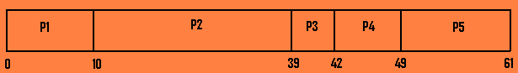
The waiting time is 0 milliseconds for process P1, 10 milliseconds for process P2, 39 milliseconds for process P3, 42 milliseconds for process P4 and 49 milliseconds for process P5. Thus the average waiting time is (0+ 10+ 39+ 42+ 49)/ 5= 28 milliseconds.
Case 2: Non preemptive SJF algorithm
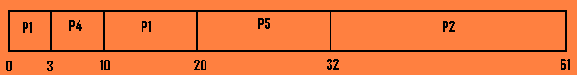
The waiting time is 10 milliseconds for P1, 32 milliseconds for process P2, 0 milliseconds for process P3, 3 milliseconds for process P4 and 20 milliseconds for process P5. Thus the average waiting time is (10+ 32+ 0+ 3+ 20)/ 5= 13 milliseconds.
Case 3: RR algorithm

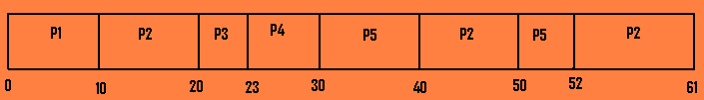
The waiting time is 0 milliseconds for process P1, 32 milliseconds for process P2, 20 milliseconds P3, 23 milliseconds for P4 and 40 milliseconds for process P5. Thus the average waiting time is (0+ 32+ 20+ 23+ 40)/ 5= 23 milliseconds.
So we see that in this case the average waiting time obtained with the SJF policy is less than that obtained with FCFS scheduling; the RR algorithm gives us an intermediate value.
Deterministic modeling is simple and fast. It gives us exact number allowing us to compare the algorithms. However, it requires exact number for input, and its answers apply only to those cases. The main uses of derministic modeling are in describing scheduling algorithms and proving examples.

2. Queuing Models: The computer system is described as a network of servers. Each server has a queue of waiting processes. The CPU is a server with its ready queue, as is the I/O system with its device queues. Knowing arrival rates and service rates, we can compute utilization, average queue length, average wait time and so on. This area of study is called queuing-network analysis.
As an example, let n be the average queue length (excluding the process being serviced), let W be the average waiting time in the queue and let λ be the average arrival rate for new processes in the queue (such as three processes per second).
We expect that during the time W that a process waits, λ ∗ W new processes will arrive in the queue. If the system is in a steady state, then the number of processes leaving the queue must be equal to the number of processes that arrive. Thus,
n = λ ∗ W This equation, known as Little’s formula, is particularly useful because it is valid for any scheduling algorithm and arrival distribution.
We can use Little’s formula to compute one of the three variables, if we know the other two. For example, if we know that 7 processes arrive every second (on average), and that there are normally 14 processes in the queue, then we can compute the average waiting time per process as 2 seconds.

3. Simulation Model: To get a more accurate evaluation of scheduling algorithms, we can use simulations. The simulator has a variable representing a clock; as this variable’s value is increased, the simulator modifies the system state to reflect the activities of the devices, the processes, and the scheduler. As the simulation executes, statistics that indicate algorithm performance are gathered and printed.
The data to drive the simulation can be generated in several ways. The most common method uses a random-number generator, which is programmed to generate processes; CPU burst times, arrivals, departures and so on, according to probability distributions. The distributions can be defined mathematically (uniform, exponential, Poisson) or empirically. If a distribution is to be defined empirically, measurements of the actual system under study are taken. The results define the distribution of events in the real system; this distribution can be used to drive the simulation.
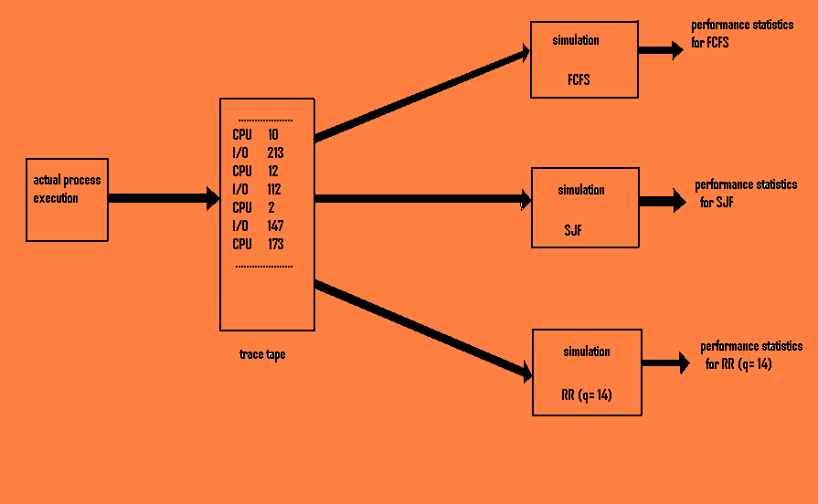
Evaluation of CPU schedulers by simulation
A distribution-driven simulation may be inaccurate, however, because of relationships between successive events in the real system. The frequency distribution indicates only how many instances of each event occur; it doesn’t indicate anything about the order of their occurrence. This problem is solved by using trace tapes. Trace tapes are created by monitoring the real system and recording the sequence of actual events. This sequence is then used to drive the simulation. Trace tapes provide an excellent way to compare two algorithms on exactly the same set of real inputs.
Disadvantages: - It can be expensive.
- Often requires hours of computer time.
- Trace tapes can require large amounts of storage space.
- The design, coding, and debugging of the simulator can be a major task.
Inter process communication (IPC)
Process executing concurrently in the operating system may be either independent processes or cooperating processes.
A process is independent if it can not be affected by the other processes executing in the system. Any process that does not share data with any other process is independent.
A process is cooperating if it can affect or be affected by the other processes executing in the system. Clearly, any process that shares data with other processes is a cooperating process.
There are many reasons for providing an environment that allows process cooperation:
- Information sharing: Since several users may be interested in the same piece of information, we must provide an environment to allow concurrent access to such information.
- Computation speedup: If we want a particular task to run faster, we must break it into subtasks, each of which will be executing in parallel with the others which can only be achieved if the computer has multiple processing elements (such as CPUs or I/O channels).
- Modularity: It is useful in constructing a system in modular fashion, dividing the system functions into separate processes or threads.
- Convenience: It is also useful when a user works on many tasks at the same time. For instance, a user may be editing, printing and compiling in parallel.
Cooperating processes require an inter-process communication mechanism that will allow them to exchange data and information. There are two fundamental models of inter-process communication:
1. Shared memory: In this model a region of memory that is shared by cooperating processes is established. Processes can then exchange information by reading and writing data to the shared region.
2. Message passing: In this model communication takes place by means of messages exchanged between the cooperating processes.
Shared memory model  It allows maximum speed and convenience of communication, as it can be done at memory speeds when within the computer.  It is faster than message passing.  In this model system calls are required only to establish shared-memory regions. Once shared memory is established, all accesses are treated as routine memory accesses and no assistance from the kernel is required. | Message sharing model  It is useful for exchanging smaller amounts of data, because no conflicts need be avoided.  It is also easier to implement than is the shared memory for inter-computer communication.  Message-passing systems are typically implemented using system calls and thus require the more time-consuming task of kernel intervention.

Shared memory systems
- IPC using shared memory requires communicating processes to establish a region of shared memory.
- Typically a shared memory region resides in the address space of the process creating the shared memory segment. Other processes that wish to communicate using this shared memory segment must attach it to their address space.
- Normally operating system tries to prevent one process from accessing another process’s memory. Shared memory requires that two or more processes agree to remove this restriction. Then only they can exchange information by reading or writing data in the shared areas.
- The form of data and location are determined by these processes and are not under the operating system’s control.
- The processes are also responsible for ensuring that they are not writing to the same location simultaneously.
- For sharing of data between the processes (one being the producer process and another being the consumer process) there should be available a buffer of items that can be filled by the producer and emptied by the consumer. The producers are synchronized, so that the consumer doesn’t try to consume an item that has not yet been produced.
- Two types of buffers can be used: One being the unbounded buffer which places no limit on the size of the buffer. The consumer may have to wait for new items, but the producer can always produce new items. And another being the bounded buffer which assumes a fixed buffer size. In this case, the consumer must wait if the buffer is empty, and the producer must wait if the buffer is full.

Message-Passing systems
- In this type the operating system provides the means for the cooperating processes to communicate with each other via a message passing facility.
- It provides a mechanism to allow processes to communicate and to synchronize their actions without sharing the same address space and is particularly useful in a distributed environment, where the communicating processes may reside on different computers connected by a network.
- A message passing facility provides at least two operations: send (message) and receive (message). Messages sent may be of fixed or variable size.
- For fixed size message passing the system level implementation is straight forward. This makes the task of programming more difficult. For variable sized message passing the system level implementation is more complex but the programming task becomes simpler.

Mutual Exclusion
This is the condition when at least one resource must be held in a non-sharable mode; that is, only one process at a time can use the resource. If another process requests that resource, the requesting process must be delayed until the resource has been released.
Mutual exclusion needs to be enforced only when processes access shared modifiable data. When processes are performing operations that do not conflict with one another they should be allowed to proceed concurrently. When a process is accessing shared modifiable data, the process is said to be in a critical section. To avoid the confusion arising due to the interruption of one process into another one’s execution it must be ensured that when one process is in a critical section, all other processes (at least those that access the same shared modifiable data) are excluded from their own critical sections. While one process is in its critical section, other processes may certainly continue executing outside their critical sections. When a process leaves its critical section, then one other process waiting to move into its own critical section is allowed to proceed. In a critical section the process has exclusive access to shared modifiable data, and all other processes currently requiring access to that are kept waiting.

Centralized Approach
In a centralized approach to provide mutual exclusion, one of the processes in the system is chosen to coordinate the entry to the critical section. Each process that wants to invoke mutual exclusion sends a request message to the coordinator. On receiving a request message, the coordinator checks to see whether some other process is in its critical section. If no process is in its critical section, the coordinator sends a reply message; otherwise the request is queued. When the process receives a reply message from the coordinator, it can proceed to enter its critical section. After exiting its critical section, the process sends a release message to the coordinator and proceeds with its execution. When the coordinator receives a release message, it removes one of the request messages from the queue and sends a reply message to some other requesting process.
This scheme requires three messages per critical section entry: a request, a reply and a release.

Fully Distributed Approach
This approach uses an algorithm based on the event-ordering scheme.
When a process Pi wants to enter its critical section, it generates a new timestamp, TS, and sends message request (Pi, TS) to all processes in the system (including itself). On receiving a request message, a process may reply immediately (i.e. send a reply message back to Pi), or it may defer sending a reply back (because it is already in its critical section, for example). A process that has received a reply message from all other processes in the system can enter its critical section; the process sends reply messages to all its deferred requests.
The decision whether process Pi replies immediately to a request (Pj, TS) message or defers its reply is based on three factors:
- If process Pi is in its critical section, then it defers its reply to Pj.
- If process Pi does not want to enter its critical section, then it sends a reply immediately to Pj.
- If process Pi wants to enter its critical section but has not yet entered it, then it compares its own request timestamp with the timestamp of the incoming request made by process Pj. If its own request timestamp is greater than that of the incoming request, then it sends a reply immediately to Pj (Pj asked first). Otherwise the reply is deferred.

This algorithm has the following advantages:
  - Mutual exclusion is obtained.
  - Freedom from deadlock is ensured.
  - Freedom from starvation is ensured, since entry to the critical section is scheduled according to the timestamp ordering. The timestamp ordering ensures that processes are served in FCFS order.
  - The number of messages per critical section is 2∗ (n-1). This number is the minimum number of required messages per critical section entry when processes act independently and concurrently.

Illustration of the algorithm:
Let us consider a system of three processes P1, P2, and P3. Suppose that processes P1 and P3 want to enter their critical sections. Process P1 then sends a message request (P1, timestamp=10) to processes P2 and P3, while process P3 sends a message request (P3, timestamp=4) to processes P1 and P2. when process P2 receives these request messages, it replies immediately. When process P1 receives the request from process P3, it replies immediately, since the timestamp (10) on its own request message is greater than the timestamp (4) for process P3. When process P3 receives the request message from process P1, it defers its reply, since the timestamp (4) on its message request is less than the timestamp (10) for the message from process P1. On receiving replies from both process P1 and P2, process P3 can enter its critical section. After exiting its critical section, process P3 sends a reply to process P1, which can enter its critical section.

Because this scheme requires the participation of all the processes in the system it has three undesirable conditions:
➔The processes need to know the identity of all other processes in the system. When a new process joins the group of processes participating in the mutual-exclusion algorithm, the following actions should be taken:
1. The process must receive the names of all the other processes in the group.
2. The name of the new process must be distributed to all other processes in the group.
This task is not very simple.
➔If one process fails, then the entire scheme collapses.
➔Processes that have not entered their critical section must pause frequently to assure other processes that they intend to enter the critical section.

Deadlock
A process in a multiprogramming environment is said to be in a state of deadlock if it is waiting for a particular event which will not occur. A deadlock is a situation where a group of processes are permanently blocked as a result of each process having acquired a subset of the resources needed for its completion and waiting for release of the remaining resources held by others in the same group- thus making it impossible for any of the processes to proceed. The following graph presents a high level view of a deadlock state where:
Task T1 has a lock on resource R1 (indicated by the arrow from R1 to T1) and has requested a lock on resource R2 (indicated by the arrow from T1 to R2).
Task T2 has a lock on resource R2 (indicated by the arrow from R2 to T2) and has requested a lock on resource R1 (indicated by the arrow from T2 to R1).
Because neither task can continue until a resource is available and neither resource can be released until a task continues, a deadlock state exists.
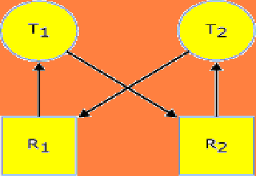

For example, assume that two processes, P1 and P2, are interleaved in such a way that at some point process P1 is granted the use of the printer, and P2 manages to seize a disk drive. In this case, the two processes are deadlocked, as neither of them can acquire the balance of the resources that it needs to make further progress. As a result, neither of the process can complete its execution and release the resources that it owns.
There are four necessary conditions for deadlock:
1. Process claim exclusive control of the resources they require (mutual exclusion condition).
2. The process holds the resources already allocated to them while waiting for additional resources (hold and wait condition).
3. Resources can’t be removed from the process holding them until the resources are used to completion (no preemption condition).
4. A circular chain of processes exist in which each process holds one or more resources that are requested by the next process in the chain (circular wait condition).

Deadlock Prevention
The basic philosophy of deadlock prevention is to deny at least one of the four necessary conditions for deadlocks. Mutual exclusion is usually difficult to dispense with, so it is customary to prevent one or more of the remaining three conditions.
Some conditions should be taken into account while executing the deadlock prevention:
➢Each process must request all its required resources at once and can’t proceed until all have been granted (i.e. all or none).
➢ If a process is already having some resources and is denied a further request that process must release its original resources and request them again together with the additional resources (i.e. the hold-and-wait condition is eliminated). But it can lead to indefinite postponement of a particular job.
➢ If a process is allocated resources of a given type it may subsequently request only those types of resources later in ordering.
➢ The no-preemption deadlock can be denied by allowing preemption, that is, by authorizing the system to revoke ownership of certain resources from blocked processes. Since preemption is involuntary from the point of view of the affected process, the operating system must be charged with saving the state and restoring it when the process is later resumed.
➢ The circular wait condition is prevented by linear ordering of different types of system resources. Deadlock is prevented by requiring all processes to request and acquire their resources in a strictly increasing order of the specified system resource classes.

Deadlock Avoidance
➢The basic idea of deadlock avoidance is to grant those requests for available resources that cannot possibly result in a state of deadlock.
➢This strategy is usually implemented by having the resource allocator examine the effects of granting a particular request. If granting of the resource can not possibly lead to a deadlock, the resource is granted to the requestor. Otherwise, the requesting process is suspended until such time when its pending request can be safely granted.
➢Deadlock avoidance requires all processes to state (preclaim) their maximum resource requirements prior to the execution. Naturally, processes whose stated resource requirements exceed the total capacity of the system are not admitted for execution.
Resource Allocator
The resource allocator keeps track of the number of allocated and the number of available resources of each type, in addition to recording the remaining number of resources pre-claimed but not yet requested by each process. A process that requests a temporarily unavailable resource is made to wait. If the requested resource is available for allocation, the resource allocator examines whether granting of the request can lead to a deadlock by checking whether each of the already active processes could safely complete, in case all such processes exercise all of their remaining options by acquiring resources that they are entitled to by virtue of the remaining claims. If so, the system state after the contemplated allocation is safe, and the resource is allocated to the requesting process. Alternatively, granting of the resource could potentially lead to a deadlock state, and the resource allocator suspends the requesting process until the desired resource can safely be granted.
Resource Allocation Graph Algorithm
➢Maintains a graph with a directed edge from each process to each resource it might request (it needs a prior knowledge).
➢Allocated resources reverse the edge direction.
➢Released resource returns the edge to its original direction.
➢The algorithm a resource only if it can do that without creating a cycle in the graph.
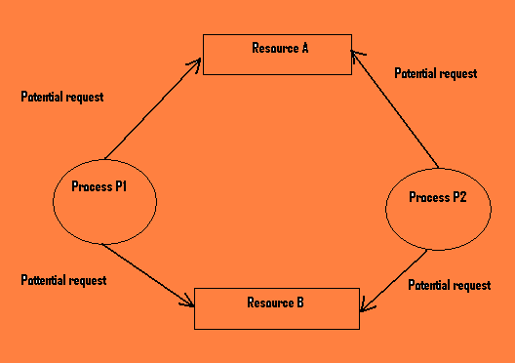

Dijkstra’s Banker’s algorithm (deadlock avoidance algo.)
Consider the allocation of a quantity‘t’ of identical tape drives.
➢An operating system shares a fixed number of equivalent tape drives‘t’ among a fixed number of users, u. Each user specifies in advance the maximum number of tape drives he will need during the execution of his job.
➢A user may obtain or release tape drives one by one. Sometimes user may have to wait to obtain additional tape drives but operating system guarantees a finite wait. The current number of tape drives allocated will never exceed that user’s stated maximum need.
➢If the operating system is able to satisfy a user’s maximum need for tape drives then the user guarantee that the tape drives will be used and released to operating system within a finite time.
Safe State
A system is in safe state only if there exists a safe sequence of processes P1, P2… Pn where:
- For each Pi, the resources that Pi can still request can be satisfied by the currently available resources plus the resources help by all Pj, j<i.
-In other words the state of a system is said to be safe state if it is possible for the operating system to allow all the current users to complete their job within a finite time by proper allocation of the resources.
-If a system is in safe state then there is no deadlock; but if the system is deadlocked then it is in unsafe state.
-An example of a safe state is given as follows:
Current Loan Maximum need
User1 1 4
User2 4 6
User3 5 8
Available: 2

User1, User2, and User3 have the current resources 1, 4, 5 respectively and their maximum need is 4, 6, and 8 respectively. There are total of 2 resources. This state is called safe state because it is still possible for all three users to finish. The system has two resources in its disposal. It may be given to user2 to fulfill its need. After completion of user2’s job it will release all the 6 resources. Then operating system may assign 3 to user1 and another 3 to user3 to fulfill their needs.
Thus a key to a state being safe is that there should be at least one way for all users to finish.

Example of unsafe state:
Current loan Maximum need
User1 8 10
User2 2 5
User3 1 3
Available: 1
Since the total available resource is 1; by no means all the users can fulfill their jobs. So it is called unsafe state.

Banker’s Algorithm for Resource Allocation
➢Mutual exclusion, no preemption, wait-for conditions are allowed but processes do claim exclusive use of the resources they require.
➢Processes are allowed to hold resources while requesting and waiting for additional resources and resources may not be preempted from a process holding those resources.
➢Request can be done for one resource at a time. If the request is denied; user have to wait for a finite time until request is granted.
➢System grant request that result in safe state only. If the request would result in an unsafe state then it is repeatedly denied; until that request eventually be satisfied.
Weakness in Banker’s algorithm
➢Algorithm requires that there be a fixed number of resources to allocate. Since resources frequently require service, either because of breakdowns or preventive maintenance we can’t count the number of resources constantly remaining fixed.
➢Algorithm requires population of users remain fixed. In today’s multiprogrammed system the user population is constantly changing.

Deadlock Detection
If a system doesn’t employ either deadlock prevention or a deadlock avoidance algorithm, then a deadlock situation may occur. In this environment, the system must provide:
∗An algorithm that examines the state of the system to determine whether a deadlock has occurred.
∗An algorithm to recover from the deadlock.
These two requirements as they pertain to systems with only a single instance of each resource type, as well as to systems with several instances of each resource type.
Single Instance of Each Resource Type
In Operating Systems a special resource-allocation graph algorithm can be used to detect whether there is any deadlock in the system. A resource-allocation graph is a directed graph consisting of two different types of nodes P = P₁, P₂... P_{n}, the set consisting of all active processes in the system, and R = R₁, R₂... R_{m}, the set consisting of all resource types in the system.
A directed edge from process P_{i} to resource R_{j} is denoted by P_{i} R_{j} and means that process P_{i} requested an instance resource type R_{j}, and is currently waiting for that resource. A directed edge from resource type R_{j} to process P_{i}, is denoted by R_{j} P_{i} and means that an instance of resource type R_{j} has been allocated to process P_{i}.
The following figure illustrates a resource-allocation graph where processes are denoted by circles and resources by squares. Notice that if there is a circular wait among the processes, then it implies that a deadlock has occurred.
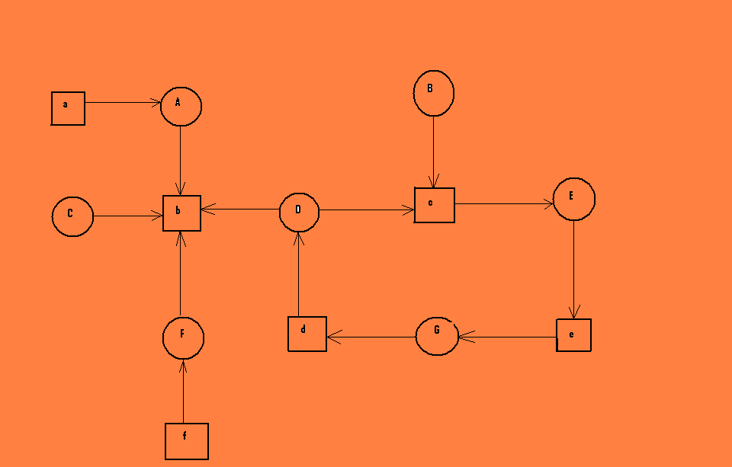
Given a resource allocation graph in which each resource type has exactly one instance, your job is to determine whether there is a deadlock in the system. In case a deadlock exists, you must also show the sequence of processes and resources involved.
Several Instance of a Resource Type
The wait for graph scheme is not applicable to a resource allocation system with multiple instances of each resource type.
Deadlock Recovery
When a detection algorithm determines that a deadlock exists, several alternatives are available. One possibility is to inform the operator that a deadlock has occurred and let the operator deal with the deadlock manually. Another possibility is to let the system recover from the deadlock automatically; which is done in two ways:
Process termination
Abort all deadlock processes. This method clearly will break the deadlock cycle, but at great expense since the deadlocked processes may have computed for a long time, and the results of these partial computations must have to be discarded and probably will have to be recomputed later.
Abort one process at a time until the deadlock cycle is eliminated. This method incurs considerable overhead, since, after each process is aborted, a deadlock detection algorithm must be invoked to determine whether any processes are still deadlocked. Aborting a process may not be easy. If the process was in the midst of updating a file, terminating it will leave that file in an incorrect state. Similarly, if the process was in the midst of printing data on a printer, the system must reset the printer to a correct state before printing the ext job.
If the partial termination method is used, then we must determine which deadlocked process (or processes) should be terminated. This determination is a policy decision, similar to CPU-scheduling decisions and is done from economic point of view.
Resource preemption
To implement this method we successively preempt some resources from processes and give these resources to other processes until the deadlock cycle is broken. This gives rise to three issues:
1. Selecting a victim. This is deciding which resources and which processes are to be preempted and depends on some parameters such as the number of resources a deadlocked process is holding and the amount of time the process has thus far consumed during its execution.
2. Rollback. After preemption of a resource from a process the process can’t continue with its normal execution since it misses some needed resource. Rolling back includes keeping the process in a safe state so that it can be restarted form that state.
3. Starvation. If the preemption of the resource is done basing on priority then it may happen that a particular resource is always preempted from a process having low priority. Then this will give rise to starvation of the process for the resource. That’s why it is necessary to ensure that a process can be picked as a victim only a finite number of times. The most common solution is to keep the record of the number of rollbacks of a particular process.
Memory Management
By storage organization we mean the manner in which the main memory is viewed, i.e. whether to place a single user or multiple users in main memory at a time, whether to give each of them same amount of space or to divide main memory into portions called partitions of different sizes. Memory management is thus defined as the technique of managing or sharing the primary or main memory.
Memory management strategy
Memory management strategies are used to obtain best possible use of the main memory resources. The memory management strategies involve three things:
1. Fetch strategies
(a) Demand fetch strategies
(b) Anticipatory fetch strategies
2. Placement strategies
3. Replacement strategies
Fetch strategies: It is concerned with when to obtain next piece of program or data for transfer to the main memory from secondary memory/ storage.
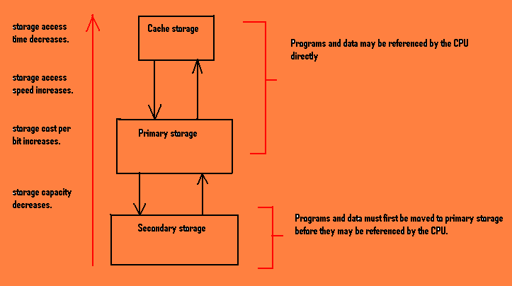
In demand fetch the next piece of program or data is brought to the main memory when it is referenced by a running program.
In anticipatory fetch the next piece of program or data is brought to the main memory well in advance by predicting that it may be required in the future.
Placement strategies: It is concerned with where in the main memory an incoming program can be placed. Types of this strategy are: first fit, best fit and worst fit storage placement strategies.
Replacement strategies: It is concerned with determining which piece of program or data will be replaced to make room for other programs.
Allocation of main memory
It can be done in two ways:
➔ Contiguous way: In this type of memory allocation the memory is usually divided into two partitions: one for resident operating system and one for the user purposes.
In case of several user processes desiring to reside in memory at the same time, the contiguous memory allocation makes it possible for each process to be contained in a single contiguous section of memory.
In this type the memory is divided into several fixed-sized partitions. Each partition may contain exactly one process. In this multiple partition method, when a partition is free, a process is selected from the input queue and is loaded into the free partition. When the process terminates, the partition becomes available for another process.
In a fixed partition scheme, the operating system keeps a table indicating which parts of memory are available and which are occupied. Initially, all memory are available and is considered one large block of available memory, a hole. When a process arrives and needs memory, the operating system searches for a hole large enough for this process. If the operating system finds one then it allocates only as much memory as is needed, keeping the rest available for future requests.
As processes enter the system, they are put into an input queue. The operating system takes into account the memory requirements of each process and the amount of available memory space in determining which processes should be given with the memory. Once a process is allocated space, it is loaded into memory, and it can then compete for the CPU. When the process terminates, it releases its memory, which the operating system may fill with another process from the input queue.
At any given time we have a set of holes of various sizes scattered throughout the memory. When a process arrives and needs memory, the system searches the set for a hole that is large enough for this process. If the hole is too large it is split into two parts; one part is allocated to the arriving process, and the other part is returned to the set of holes. When the process terminates, it releases its block of memory, which is then placed back in the set of holes. Memory is allocated to processes until, finally, the memory requirements of the next process can’t be satisfied- that is, no available block of memory (or hole) is large enough to hold that process.
➔ Non contiguous way: In this type of allocation the program is divided in several segments and it is at various places in the main memory.

Single Partition Memory Allocation
In this memory allocation method, the operating system resides in the low memory and the remaining memory is treated as a single partition. This single partition is available for user space. Only one job can be loaded in this user space. Consider the figure below, which depicts a single partition allocation:
The CPU scheduler selects a job from the ready queue for execution, the dispatcher loads that job in to the main memory and connect the CPU to that job. But here the main memory can take up only one job/ process at a time since the user space is treated as a single partition.
Advantages: The main advantage of this scheme is its simplicity. It does not need great expertise to understand or use such a system.
Disadvantages: The memory is not utilized fully and a lot of memory goes waste. There is poor utilization of the processors. The user’s job is limited to the size of the available main memory.
Multiple Partition Memory Allocation
This method can be implemented in three ways. These are:
1. Fixed equal multiple partitions memory management
In this memory management scheme the operating system occupies the low memory, and the rest of main memory is available for user space. The user space is divided into fixed partitions. The partition sizes depend upon the operating system. For example the total main memory size is 6MB. 1MB is occupied by the operating system, and the remaining 5MB is partitioned into 5 equal fixed partitions (5∗1MB).
A partition of main memory which is wasted with in a partition is said to be internal fragmentation whereas the wastage of an entire partition is said to be external fragmentation.
Advantages:
➔This scheme supports multiprogramming.
➔Efficient utilization of the processor and I/O devices.
➔It requires no special costly hardware.
➔Simple and easy to implement.

Disadvantages:
➔This scheme suffers from internal and external fragmentation.
➔The single free area may not be large enough for a partition.
➔It does require more memory than a single partition method.
➔A job’s partition size is limited to the size of the physical memory.

2. Fixed variable partition memory management
The user space of main memory is divided into number of partitions, but the partition sizes are different. The operating system keeps a table indicating that which partitions of memory are available and which are occupied. When process arrives and needs memory, the search for a partition large enough for this process is done. If it is found then the partition is allocated to the process.
Here also the operating system occupies the low memory. There are three algorithms which are used for the memory allocation in this scheme:
First fit: Allocate the partition that is large enough. Searching can start either from low memory or high memory, and it is stopped as soon as a free partition is found that is large enough to hold the process, i.e., the partition (with the required size) which is found first is allocated.
Best fit: Allocate the smallest partition among all partitions which is large enough to hold the process, i.e., select a partition having the least internal fragmentation.
Worst fit: Search the entire partitions and select a partition which is the largest of all, i.e., select a partition which is having the maximum internal fragmentation.
Advantages:
➔This system supports multiprogramming.
➔Efficient processor utilization and memory utilization is possible.
➔Simple and easy to implement.
Disadvantages:
➔This scheme suffers from internal and external fragmentation.
➔Possible large external fragmentation.

3. Dynamic partitions memory management
In this method, partitions are created dynamically so that each process is loaded into partition of exactly the same size as that of the process. In this scheme the entire user space is treated as a single big hole. The boundaries of partitions are dynamically changed and the boundaries depend on the size of the processes.
Advantages:
➔In this scheme partitions are changed dynamically. So this scheme prevents internal fragmentation.
➔Efficient memory and processor utilization.
Disadvantages: This scheme also suffers from external fragmentation.

Coalescing: When a job is finished, it releases its block of memory, which is then placed back in the set of holes. If the new hole is adjacent to other holes, these adjacent holes are merged together to form one larger hole. This is called coalescing.

Storage compaction: It is a solution made to external fragmentation. If after coalescing holes are still distributed then storage compaction is used. It moves all occupied storage to one end and all the holes to another end (i.e. all internal and external fragments are brought together).
Drawback: When this is done the system has to be halted which leads to erratic response time. It involves relocating the job at different places so that no information will be lost after reloading the program.
Paging
It is an efficient memory management scheme because it is not contiguous memory allocation method. The previous allocation methods support the contiguous memory allocation where the entire process is loaded in to a single partition. But in the paging scheme the process is divided in to small parts which are loaded in to else where in the main memory.
The basic idea of paging is that the physical memory (main memory) is divided in to fixed sized blocks called frames and the logical address space (user job) is divided in to fixed sized blocks called pages. But the page size and the frame size should be equal and the size depends on the operating system. Generally the page size is 4KB.
The operating system maintains a data structure that is page table. It is used for mapping purpose. The page table specifies some useful information about the process, i.e. it tells which frames are allocated, which frames are available and how many total frames are there, and so on. The general page table consists of two fields, one is page number and the other one is the frame number.
Every address generated by the CPU (i.e. the logical address) is divided into two parts, one is the page number and the other is the page offset or displacement. The page number is used as an index in the page table. The pages are loaded into available free frames in the physical memory. The mapping between page number and frame number is done by the page map table. The page map table specifies which page is loaded in which frame.
Advantages:
➔It supports time sharing system.
➔It does not get affect from fragmentation.
➔It supports virtual memory.
➔Sharing of common code is possible.
Disadvantages:
➔This scheme suffers from page breaks.
➔If the number of pages is high, it is difficult to maintain page tables.

Virtual Storage
Virtual memory involves the separation of logical memory as perceived by users from physical memory. This separation allows an extremely large virtual memory to be provided for programmers when only a smaller physical memory is available. Virtual memory makes the task of programming much easier, because the programmer no longer needs to worry about the amount of physical memory available. The virtual address space of a process refers to the logical (or virtual) view of how a process is stored in memory.
The basic idea behind virtual memory is that the combined size of the program, data, and stack may exceed the amount of physical memory available for it. The operating system those parts of the program currently in use in the main memory, and rest on the disk (treated as the virtual memory). Virtual memory can also work in multiprogramming system. It also allows files and memory to be shared by two or more processes through page sharing.

Paging
The virtual address space is divided into units called pages. The corresponding units in the physical/ main memory are called page frames. The pages and the page frames are always of same size. Consider an example where a computer can generate 16-bit addresses, from 0 up to 64K. These are the virtual addresses. This computer, however, only has 32K of physical memory, so although 64K programs can be written, they can not be loaded into memory in their entirety and run. A complete copy of a program’s core image, up to 64K, must be present on the disk, however, so that pieces can be brought in as needed. With 64K of virtual memory and 32K of physical memory, we have 16 virtual pages and 8 page frames. Transfers between memory and disk are always in units of a page.
The ability to map the 16 virtual pages onto any of the eight page frames by setting the MMU’s (Memory Management Unit) map appropriately does not solve that the virtual address space is larger than the physical memory. Since we have only 8 physical page frames, only 8 of virtual pages can be mapped onto physical memory. The others are not mapped at that time. In the actual hardware, a present/ absent bit in each entry keeps the track of whether the page is mapped or not. If the MMU notices that the page is unmapped, then it causes the CPU to trap to the operating system. This trap is called a page fault. The operating system picks a little used page frame and writes its contents back to the disk. It then fetches the page just referenced into the page frame just freed, changes the map, and restarts the trapped instruction.
Page Tables
The virtual address is split into a virtual page number (high order bits) and an offset (low order bits). The virtual page number is used as an index into the page table to find the entry for that virtual page. From the page table entry, the page frame number is found. The page frame number is attached to the high order end of the offset, replacing the virtual page number, to form a physical address that can be sent to the memory. The purpose of the page table is to map virtual pages onto the page frames.

Page Replacement Algorithms
When a page fault occurs, the operating system has to choose a page to remove from the memory to make room for the page that has to be brought in. if the page to be removed has been modified while in memory, it must be rewritten to the disk to bring the disk copy up to date. If, however, the page has not been changed, the disk is already up to date, so no rewrite is needed. The page to be read in just overwrites the page being evicted. Some of the algorithms used for replacement of the pages are described below:
- The optimal page replacement algorithm: This algorithm simply says that the page with highest label should be removed. If one page will not be used for 8 million instructions and another page will not be used for 6 million instructions, removing the former pushes the page fault that will fetch it back as far into the future as possible. The only problem is that it is unrealizable since the operating system has no way of knowing when each of the pages will be referenced next.
- The first in first out page replacement (FIFO) algorithm: The operating system maintains a list of all pages currently in memory, with the page at the head of the list as the oldest one and the page at the tail as the most recent arrival. On a page fault, the page at the head is removed and the new page is added to the tail of the list. But in computers FIFO in its pure form is rarely used.
- The least recently used (LRU) page replacement algorithm: A good approximation to the optimal algorithm is based on the observation that pages that have been heavily used in the last few instructions will probably be heavily used again in the next few. Conversely, pages that have not been used for ages will probably remain unused for a long time. Basing on this idea, when a page fault occurs, by using this algorithm the page is thrown out which has been unused for the longest time.

It might seem that the more page frames the memory has, the fewer page faults a program will get. Surprisingly, this is not always the case. Belady et al. (1969) discovered a counterexample, in which FIFO caused more page faults with four page frames than three. This strange situation has become known as Belady’s anomaly.

Segmentation

The virtual memory in case of pages is one-dimensional because the virtual address go from 0 to some maximum address, one address after another. For many problems, having two or more separate virtual address spaces may be much better than having only one.
Consider a program having large number of variables. The chunk of address space allocated for the symbol table may fill up, but there may be lots of room in other tables. The compiler could, of course, simply issue a message saying that the compilation cannot continue due to too many variables, but doing so does not seem very sporting when unused space is left in the other tables.
A straightforward and extremely general solution is to provide the machine with many completely independent address spaces, called segments. Each segment consists of a linear sequence of addresses, from 0 to some maximum. The length of each segment may be anything from 0 to the maximum allowed. Different segments may, and usually do, have different lengths. Moreover, segment lengths may change during execution. For example, the length of a stack segment may be increased whenever something is pushed onto the stack and decreased whenever something is popped off the stack.
Since each segment constitutes a separate address space, different segments can grow or shrink independently, without affecting each other. A segment can fill up but segments are usually large, so this occurrence is rare. To specify an address in this segmented or two dimensional memory, the program must supply a two-part address, a segment number and an address within the segement.

Files
A file is a named collection of related information that is recorded on the secondary storage. From user’s point of view, a file is the smallest allotment of logical secondary storage; that is data can’t be written to the secondary storage unless they are with in a file.
Commonly files represent programs (both source and object forms) and data. Files may be free form, such as text files, or may be formatted rigidly. In general, a file is a sequence of bits, bytes, lines or records, the meaning of which is defined by the file’s creator and the user.
The information in a file is defined by its creator. Many different types of information may be stored in a file- source programs, object programs, executable programs, numeric data, text, payroll records, graphic images, sound recordings and so on. A file has certain defined structure, which depends on its type.
A text file is a sequence of characters organized into lines (and possibly pages). A source file is a sequence of subroutines and functions, each of which is further organized as declarations followed by executable statements. An object file is a sequence of bytes organized into blocks understandable by the system’s linker. An executable file is a series of code sections that the loader can bring into memory and execute.
File System
Managing the files in the secondary storage is known as file system. It enables the user to create or delete a file, manipulate a file, share a file or transfer the information between files and provide the files the backup files.
File Attributes
A file’s attributes vary form one operating system to another but typically consist of the following:
- Name. A name is a string of characters, such as example.c. It is given for human convenience.
2) Identifier. This unique tag, usually a number, identifies the file within the file system; it is a non-human-readable name for the file.
3) Type. This information is needed for systems that support different types of files.
4) Location. This information is a pointer to a device and to the location of the file on that device.
5) Size. The current size of the file (in bytes, words, or blocks) and possibly the maximum allowed size are included in this attribute.
6) Protection. Access-control information determines who can do reading, writing, executing and so on.
7) Time, date and user identification. This information maybe kept for creation, last modification and last use. These data can be useful for security, protection and usage monitoring.
File Operations
A file is an abstract data type. To define a file properly, we need to consider the operations that can be performed on files such as to create a file, to write a file, to read a file, to reposition the files, to delete the files and to truncate a file. Let’s examine it:
1. Creating a file. Two steps are necessary to create a file. First, space in the file system must be found for the file. Second, an entry for the new file must be made in the directory.
2. Writing a file. To write a file, we make a system call specifying both name of the file and the information to be written to the file. Given the name of the file, the system searches the directory to find the file’s location. The system must keep a write pointer to the location in the file where the next write is to take place. The write pointer must be updated whenever a write occurs.
3. Reading a file. To read a file, we use a system call that specifies the name of the file and where in memory the next block of the file should be put. Again, the directory is searched for the associated entry, and the system needs to keep a read pointer, which is often updated, to the location in the file where the next read is to take place.
Because a process is usually either reading from or writing to a file, the current operation location can be kept as a per-process current-file-position pointer. Both the read and write operations use this same pointer for saving and reducing system complexity.
4. Repositioning within a file. The directory is searched for the appropriate entry and the current file position pointer is repositioned to a given value. This file operation is also known as a file seek.
5. Deleting a file. To delete a file, we search the directory for the named file and then all file space is released so that it can be used by other files, and then the directory entry of the file is erased.
6. Truncating a file. The user may want to erase the contents of a file but keep its attribute. Rather than forcing the user to delete the file and then recreate it, this function allows all attributes to remain unchanged except for the file length, but lets the file be reset to length zero and its file space released.
Together with these six operations there are some other common operations like appending new information to the end of an existing file and renaming an existing file.
Information which are associated with an open file:
File pointer. It keeps track of the location where the user can read or write the information.
File open count. It keeps track of the number of times the file is opened or closed.
a) Disk location of the file. Most file operations require the system to modify data within the file. The information needed to locate the file on disk is kept in memory so that the system does not have to read it from disk for each operation.
b) Access rights. Each process opens a file in an access mode. This information is stored on the per-process table so that the operating system can allow or deny subsequent I/O requests.

The sequential order in which the data are categorized:
Bits➔ Bytes➔ Character➔ Field➔ Record➔ Files➔ Database
A record can be of two types:
Physical Record: A physical record or a block is a unit of information actually read from or written to the device.
Logical Record: A logical record is a collection of data as one unit.
If each physical record is equal to exactly one logical record then the file is said to contain unblocked records else the file is said to contain blocked records.
Records can be of fixed length or of variable length.
Buffer
Buffers are temporary memory locations in the main memory that store data while they are transferred between two devices or between a device and an application.
Spaces are provided in the primary memory to hold several physical blocks of file at once. Each of these spaces is called a buffer. Most common are the double buffers where two buffers are there. The records generated by a process are initially kept in the first buffer until it is full then the transfer of records start from this buffer to the secondary storage. It allows I/O to occur in parallel with computation.
File Organization
It is concerned with the manner in which records are stored in the secondary storage. Three ways in which records are stored in the secondary storage are:

Input/ Output

One of the main functions of an operating system is to control all the computer’s input/ output devices. It must issue commands to the devices, catch interrupts and handle errors. It should also provide an interface between the devices and the rest of the system that is simple and easy to use. To the extent possible, the interface should be the same for all devices (device independence).

Principles of I/O hardware
Different people look at I/O hardware in different ways. Electrical engineers look at in terms of chips, wires, power supplies, motors and all the other physical components that make up the hardware. Programmers look at the interface presented to the software- the commands the hardware accepts, the functions it carries out, and the errors that can be reported back.

I/O devices
I/O devices can be roughly divided into two categories:
- Block Devices: It is the one that stores information in fixed-size blocks, each one with its own address. Common block sizes range from 128 bytes to 1024 bytes. The essential property of a block device is that it is possible to read or write each block independently of all the other ones i.e. at any instant, the program can read or write any of the blocks. Disks are block devices.
- Character Devices: It delivers or accepts a stream of characters, without regard to any block structure. It is not addressable and does not have any seek operation. Terminals, line printers, paper tapes, punched cards, network interfaces, mice (for pointing), rats (for psychology lab experiments), and most other devices that are not dick-like can be seen as character devices.

Device Controllers
I/O units typically consist of a mechanical component and an electronic component. It is possible to separate the two portions to provide a more modular and general design. The electronic component is called the device controller or adapter. The hardware part which actually communicates with the I/O device requested for is called the device controller. The mechanical component is the device itself. Many controllers can handle two, four or even eight identical devices. The operating system nearly always deals with the controller, not the device.
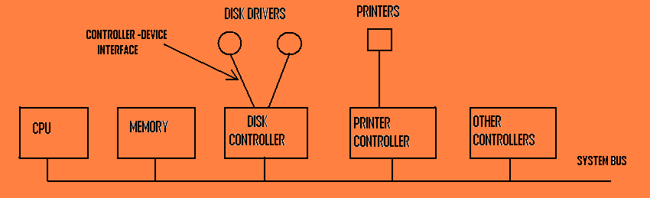
A model for connecting the CPU, memory, controllers and I/O devices.

Preamble: The preamble is written when the disk is formatted, and contains the cylinder and sector number, the sector size and similar data.
The controller’s job is to convert the serial bit stream into a block of bytes and perform any error correction necessary. The block of bytes is first assembled bit by bit in a buffer inside the controller. After its checksum has been verified and the block declared to be error free, it can be copied to the main memory.
Each controller has a few registers that are used for communicating with the CPU. On some computers, these registers are part of the regular memory address space. This scheme is called memory mapped I/O. other computers use a special address space for I/O, with each controller allocated a certain portion of it. The assignment of I/O addresses to devices is made by bus decoding logic associated with the controller.

The operating system performs I/O by writing commands into the controller’s registers. Many of the commands have parameters, which are also loaded into the controller’s registers. When a command has been accepted, the CPU can leave the controller alone and go off to do other work. When the command has been completed, the controller causes an interrupt in order to allow the operating system to gain control of the CPU and test the results of the operation. The CPU gets the result and device status by reading one or more bytes of information from the controller’s registers.

Direct Memory Access
While transfer of data from the I/O to the main memory the CPU gets engaged all the time and its time is wasted. For this reason the DMA controller is used to access the data directly from the I/O device and transfer it to the memory location without the involvement of the CPU. Hence the CPU time is saved.

To explain how the DMA works let us first consider a read operation without the use of DMA. First the controller reads the block (one or more sectors) from the driver serially, bit by bit, until the entire block is in the controller’s internal buffer. Next, it computes the checksum to verify that no read errors have occurred. Then the controller causes an interrupt. When the operating system starts running, it can read the disk block from the controller’s buffer a byte or a word at a time by executing a loop, with each iteration reading one byte or word from a controller device register and storing it in the main memory. Naturally, a programmed CPU loop to read the bytes one at a time from the controller wastes the CPU time.
DMA was invented to free the CPU from this low level work. When it is used, the CPU gives the controller two items of information, in addition to the disk address of the block: the memory address where the block is to go, and the number of bytes to transfer. After the controller has read the entire block from the device into its buffer and verified the checksum, it copies the first byte or word into the main memory at the address specified by the DMA memory address. Then it increments the DMA address and decrements the DMA count by the number of bytes just transferred. This process is repeated until the DMA count becomes zero, at which time the controller causes an interrupt. When the operating system starts up, it does not have to copy the block to memory; it is already there.

Why the controller does not just store the bytes in main memory as soon as it gets them from the disk?
Once a disk transfer has started, the bits keep arriving from the disk at a constant rate, whether the controller is ready for them or not. If the controller tried to write data directly to memory, it would have to go over the system bus for each word transferred. If the bus were busy due to some other device using it, the controller would have to wait. If the next disk word arrived before the previous one had been stored, the controller would have to store it somewhere. If the bus were very busy, the controller might end up storing quite a few words and having a lot of administration to do as well. When the block is buffered internally, the bus is not needed until the DMA begins, so the design of the controller is much simpler because the DMA transfer to memory is not time critical.

While data are being transferred from the controller to the memory, either by the CPU or by the controller, the next sector will be passing under the disk head and the bits arriving in the controller. Simple controllers just cannot cope with doing input and output at the same time, so while a memory transfer is taking place, the sector passing under the disk head is lost.
As a result, the controller will be able to read only every other block. Reading a complete track will then require two full rotations, one for the even blocks and one for the odd blocks. If the time to transfer a block from the controller to the memory over the bus is longer than the time required to read a block from the disk, it may be necessary to read one block and then skip two (or more) blocks. Skipping blocks to give the controller time to transfer data to memory is called interleaving. The idea of numbering the blocks this way is to allow the operating system to read consecutively numbered blocks and still achieve the maximum speed of which the hardware is capable.
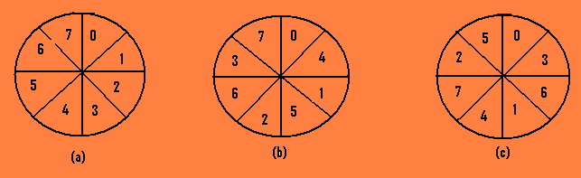
(a) No interleaving. (b) Single interleaving. (c) Double interleaving.

Goals of I/O software

- It should be device independent. It should be able to write programs that can be used with files on a floppy disk or a hard disk, without having to modify the programs for each device type.
- It should be able for uniform naming. The name of the file or a device should simply be a string and not depend on the device any way.
- It should be efficient in error handling. If the controller discovers an error, it should try to correct the error itself if it can. If it can’t, then the device driver should handle it, such as read error caused due to specks of dust on the read head, and will go away if the operation is repeated. Only if the lower layers are not able to deal with the problem should the upper layers be told about it. The software which does the job of error correction is called the device driver.
- It should be able to carry out the synchronous (blocking) as well as the asynchronous (interrupt driven) transfer. Most physical I/O is asynchronous- the CPU starts the transfer and goes off to do something else until the interrupt arrives. User programs are much easier to write if the I/O operations are blocking.
- It should take care of the sharable device or a dedicated device. Some I/O devices such as disks can be used by many users at the same time. No problems are caused by multiple users having open files on the same disk at the same time. Other devices, such as printers, have to be dedicated to a single user until that user is finished.

These goals can be achieved in an efficient way by structuring the I/O software in four layers:
1. Interrupt handler.
2. Device drivers.
3. Device independent operating system software.
4. User level software.

- Interrupt handlers
While starting an I/O operation the process blocks itself until the I/O is finished and the interrupt occurs. When the interrupt happens, the interrupt procedure does whatever it has to do in order to unblock the process that started it. The effect of the interrupt will be that a process that was previously blocked will now be able to run.
- Device drivers
Each device driver handles one device or one class of related devices. Disk driver can’t handle the printer (or print device). Each controller has got one or more registers called device register. These registers are used for taking the command from the device driver. Device driver issues the command and sees whether the command is carried out or not. It only knows how many registers are present in the device controller and what they are used for. It also knows the sectors, tracks, and cylinders, read/ write head in the devices.
Device driver accepts the request from the ‘device independent software’. If the driver is idle then the request is carried out immediately and if it is busy then it will keep it in the pending queue.
The disk driver will figure out where is the requested block on the disk and will see if the read/ write arm is at the proper position or not. Once it will find out the command to be issued, it starts writing it to the controller in the device register. Then the device controller will acknowledge the command and the device driver blocks itself (i.e. in the waiting state). When the controller finishes the job, the driver will unblock itself. After the driver wakes up it checks for any error and then passes that to the device independent software.
- Device independent I/O software
Although some of the I/O software is device specific, a large fraction of it is device-independent. The exact boundary between the drivers and the device independent software is system dependent, because some functions that could be done in device independent way may actually be done in the drivers, for efficiency or other reasons.
Functions:
➢ The basic function is to provide uniform interface a for the device driver or to the user level software.
➢ Device naming- It does the job of naming the objects such as files and I/O devices. The device independent software takes
care of mapping symbolic device names onto the proper driver.
➢ Device protection- It prevents the users from accessing devices that they are not entitled to access.
➢ Providing the device independent block size. Different disks may have different sector sizes. It is up to the device
independent software to hide this fact and provide a uniform block size to higher layers, for example by treating several
sectors as a single logical block.
➢ Buffering- It is also an issue, both for block and character devices. For block devices, the hardware generally insists upon
reading and writing entire blocks at once, but user processes are free to read and write in arbitrary units. For character
devices, users can write data to the system faster than it can be output, necessitating buffering.
➢ Storage allocation on block devices. When a file is created and filled with data, new disk blocks have to be allocated to
the file. To perform this allocation, the operating system needs a list or bit map of free blocks per disk, but the algorithm for
locating a free block is device independent and can be done above the level of the driver.
➢ Allocating and releasing dedicated devices. Some devices like magnetic tape drives, can be used only by a single process
at any given moment. It is up to the operating system to examine requests for device usage and accept or reject them,
depending on whether the requested device is available or not.
➢ Error reporting. It is done by the drivers. Most errors are highly device dependent, so only the driver knows what to do.
a typical error is caused by a disk block that has been damaged and can not be read any more. After the driver has tried
to read the block a certain number of times, it gives up and informs the device independent software. How the error is
treated from here on is device independent.
- User space I/O software
Although most of the I/O software is within the operating system, a small portion of it consists of libraries linked together with user programs, and even whole programs running outside the kernel. System calls, including the I/O system calls, are normally made by library procedures. When a C program contains the call
Count = write (fd, buffer, nbytes);
the library procedure write will be linked with the program and contained in the binary program present in memory at run time. The collection of all these library procedures is clearly part of the I/O system.

Spooling
It is a way of dealing with dedicated I/O devices in multiprogramming system. Let us take the example of a spooled device: the line printer. When the user issues a print command for a file, then that file is generated and deposited in a special directory called the spooling directory. When printer is free a special process, which is the only process having permission to use the printer’s special file, called “daemon process” executes the print command. If at the time of printing another print command is given for another file then that file is again deposited in the spooling directory in the waiting state.
Spooling is not only used for printers, but also for other situations. For example, file transfer over a network often uses network daemon. To send file somewhere, a user puts it in a network spooling directory. Later on, the network daemon takes it out and transmits it.

The below figure summarizes the I/O system, showing all the layers and the principal functions of each layer. The arrows in the figure show the flow of control.

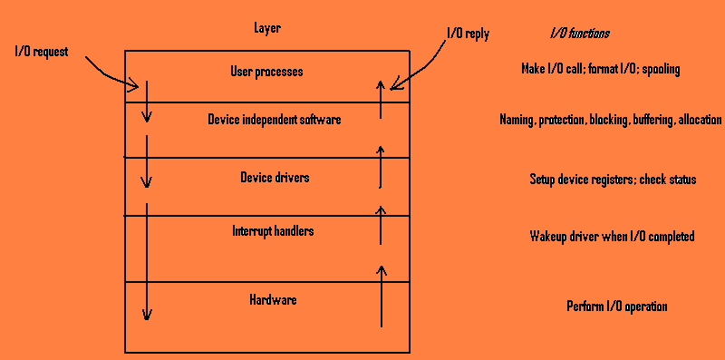

Example: when a user program tries to read a block from a file the operating system is invoked to carry out the call. The device independent software looks in the cache. If the needed block is not there, it calls the device driver to issue the request to the hardware. The process is then blocked until the disk operation has been completed.
When the disk is finished, the hardware generates an interrupt. The interrupt handler is run to discover what has happened. It then extracts the status from the device, and wakes up the sleeping process to finish off the I/O request and let the user process continue.

Disks
Disks have three major advantages over using main memory for storage:
1. The storage capacity available is much larger.
2. The price per bit is much lower.
3. Information is not lost when the power is turned off.

Disk Hardware
All disks are organized into cylinders, each one containing as many tracks as there are heads stacked vertically. The tracks are divided into
sectors, with the number of sectors around the circumference typically being 8 to 32. All sectors contain the same number of bytes, although the
sectors close to the outer rim of the disk will be physically longer than those close to the hub. The extra space is not used.

Disk Arm Scheduling Algorithm
The time to read or write a disk block is determined by three factors:
1. Seek time: The time to move the arm to the proper cylinder.
2. Rotational delay: The time for the proper sector to rotate under the head.
3. Actual transfer time.
For most disks the seek time dominates, so reducing the mean seek time can improve system performance substantially.

FCFS (first come first serve) scheduling
In this type of scheduling little can be done to optimize the seek time. Consider a disk with 40 cylinders. A request comes into read a block on
cylinder 11. While the seek to cylinder 11 is in progress, new requests come in for cylinders 1, 36, 16, 34, 9 and 12, in that order. They are
entered in to the table of pending requests, with a separate linked list for each cylinder.

When the current request (for cylinder 11) is finished, the disk driver has a choice of which request to handle next. Using FCFS, it would
go next to cylinder 1, then to 36 and so on. This algorithm would require arm motions of 10, 35, 20, 18, 25 and 3 respectively, for a total of 111
cylinders.

SSTF (shortest seek time first) scheduling
This is an alternative method where the disk driver handles the closest request next, to minimize seek time. Let the requests given be 12, 9, 16, 1,
34 and 36. With this sequence the arm motions are 1, 3, 7, 15, 33 and 2, for a total of 61 cylinders. This algorithm cuts the total arm motion
almost half compared to FCFS.

Unfortunately, SSF has a problem. Suppose more requests keep coming in while the above requests are being processed. For example, if,
after going to cylinder 16, a new request for cylinder 8 is present, that request will have priority over cylinder 1. If a request for cylinder 13
then comes in, the arm will go to 13, instead of 1. With a heavily loaded disk, the arm will tend to stay in the middle of the disk most of the
time, so requests at either extreme will have to wait until a statistical fluctuation in the load causes there to be no requests near the middle.
Requests far from the middle may get poor service. The goals of minimal response time and fairness are in conflict here.

SCAN (elevator) scheduling
In the scan algorithm, the disk arm starts at one end of the disk and moves toward the other end, servicing requests as it reaches each cylinder,
until it gets to the other end of the disk. At the other end, the direction of head movement is reversed, and servicing continues. The head contin-
-ously scans back and forth across the disk. The SCAN algorithm is sometimes called the elevator algorithm, since the disk arm behaves just
like an elevator in a building, first servicing all requests going up and then reversing to service requests the other way.

Let us consider the request queue as 98, 183, 37, 122, 14, 124, 65 and 67. Before applying the SCAN schedule the requests we need
To know the direction of head movement in addition to the head’s current position (53). If the disk arm is moving toward 0, the head will
service 37 and then 14. at cylinder 0, the arm will move toward the other end of the disk, servicing the requests at 65, 67, 98, 122, 124
and 183. If a request arrives in the queue just in front of the head, it will be serviced almost immediately; a request arriving just behind the
head will have to wait until the arm moves to the end of the disk, reverses direction, and comes back.

C-SCAN scheduling
Circular SCAN (C- SCAN) scheduling is a variant of SCAN designed to provide a more uniform wait time. Like SCAN, C-SCAN moves the
head from one end of the disk to other, servicing requests along the way. When the head reaches the other end, however, it immediately returns
to the beginning of the disk, without servicing any requests on the return trip. The C-SCAN scheduling algorithm essentially treats the cylinders
as a circular list that wraps around from the final cylinder to the first one.

LOOK scheduling
Both SCAN and C-SCAN move the disk arm across the full width of the disk. In practice, neither algorithm is often implemented this way.
More commonly, the arm goes only as far as the final request in each direction. Then, it reverses direction immediately, without going all the way
to the end of the disk. Versions of SCAN and C-SCAN that follow this pattern are called LOOK and C-LOOK scheduling, because they look
for a request before continuing to move in a given direction.

Error Handling
Disks are subject to wide variety of errors. Some of the common ones are:
- Programming error (e.g. request for non existent sector)
This error occurs when the driver tells the controller to seek to a nonexistent cylinder, read from a nonexistent sector, use a nonexistent head, or transfer to or from nonexistent memory. Most controllers check the parameters given to them and complain if they are invalid. In theory, these errors should never occur. The solution to this error is to terminate the current disk request with an error and hope it will not recur too often.
- Transient checksum error (e.g. caused by dust on the head)
These errors are caused by specks of dust in the air that get between the head and the disk surface. Most of the time they can be eliminated by just repeating the operation a few times. If the error persists, the block can be marked as a bad block. And avoided in software.
- Permanent checksum error (e.g. disk block physically damaged)
These errors are caused due to damage of the disk block permanently. Some intelligent disk controllers reserve a few tracks not normally available to user programs. When a disk drive is formatted, the controller determines which blocks are bad and automatically substitutes one of the spare tracks for the bad one. The table that maps bad tracks to spare tracks is kept in the controller’s internal memory and on the disk. This substitution is transparent to the driver.
- Seek error (e.g. the arm sent to cylinder 6 but it went to 7)
These errors are caused due to mechanical problems in the arm. The controller keeps track of the arm position internally. To perform a seek; it issues a series of pulses to the arm motor, one pulse per cylinder, to move the arm to the new cylinder. When the arm gets to its destination, the controller reads the actual cylinder number (written when the drive was formatted). If the arm is in the wrong place, a seek error has occurred.
Some controllers correct seek errors automatically, but others just set an error bit and leave the rest to the driver. The driver handles this error by issuing a RECALIBRATE command, to move the arm as far out as it will go, and reset the controller’s internal idea of the current cylinder to 0.
- Controller error (e.g. controller refuses to accept commands)
Sometimes an unusual sequence of events such as an interrupt on one drive occurring simultaneously with a RECALIBRATE command for another drive will trigger a bug and cause the controller to go into a loop or lose track of what it was doing. Controller designers usually plan for the worst and provide a pin on the chip or board, which, when set high, forces the controller to forget whatever it was doing and reset itself.

Track-at-a-time Caching
A cache is a region of fast memory which holds the copies of the actual data.
Most disk controllers include local memory to form to form cache that is sufficiently large enough to hold the entire track at a time. Once a seek is
Performed, the track is read into the cache. The disk controller then transfers any sector into the operating system.

The time required to seek a new cylinder is much more than the rotational delay and also more than the disk transfer. Some disk maintain the track-
at-a-time cache, unknown to the device independent software. If a sector that is in the cache is needed, no disk transfer is required. A dis-
-advantage of track-at-a-time caching (in addition to the software complexity and buffer space needed) is that transfers from the cache to the calling
program will have to be done by the CPU using a programmed loop, rather than letting the DMA hardware do the job.
Some controllers do track-at-a-time caching in their own internal memory instead of in the main memory, so that in future the transfer
would be done from the controller cache to the main memory by the DMA.

RAM disks
Primary use of the RAM disk is to allow some part of main memory to be reserved like an ordinary disk for storing blocks. A RAM disk has the a
advantage of having instant access (no seek or rotational delay), making it suitable for storing programs that are frequently accessed.

A RAM disk is divided into several blocks depending on how much memory has been allocated for it. Each block is the same size as the block
size used on real disks. When the RAM disk driver receives a message to read or write a block, it just finds where in the RAM disk memory
the requested block lies, and reads or writes from it, instead of from a floppy or hard disk. All the disk operations are carried out here. The
main disadvantage associated with the RAM disk is that it is volatile i.e. the content is lost when power is turned off and it can store data
temporarily.

Clocks
Clocks are essential for the operation of any timesharing system, such as:
1. They maintain the time of the day.
2. They prevent one process from monopolizing the CPU.
3. The clock software generally takes the form of a device driver, even though a clock is neither a block device, like a disk, nor a character device, like a terminal.

Clock Hardware
Two types of clocks are commonly used in computers:
➔ The simpler clocks are tied to the 110 or 220 volt power line and cause interrupt on every voltage cycle, at 50 or 60 Hz.
➔ The other kind of clock is built out of three components:
1. A crystal oscillator.
2. A counter.
3. A holding register.
When a piece of quartz crystal is properly cut and mounted under tension, it can be made to generate periodic signals of very high accuracy and one such circuit is there in the computer whose signals are fed into the counter to make it count down to zero. When the counter gets to zero, it causes a CPU interrupt. What happens next is up to the operating system.

Programmable clocks have two modes of operation:
➔One shot mode: In this mode when the clock is started it copies the value of the holding register to the counter and then decreases it with every pulse of the crystal. When the counter becomes zero it causes an interrupt and stops until it is started again by the software.
➔Square wave mode: In this mode after getting to zero and causing the interrupt the holding register is copied into the counter automatically and the whole process is repeated again and again indefinitely. This periodic interruption is known as clock ticks.

To implement a time-of-day clock, the software asks the user for the current time, which is then translated into the number of clock ticks. At every clock tick, the real time is incremented by one count. To prevent the current time from being lost when the power is turned off, some computers store the real time in a special register powered by a battery (battery backup).

Clock Software
The job of the clock hardware is just only to give interrupt at known intervals. Everything else involving time must be done by the software, the clock driver. The exact duties of the clock software or clock driver are given by:
- Maintaining the time of the day. It means taking care of the real time. It just requires incrementing a counter at each clock tick. The only thing to watch out for is the number of bits in the time-of-day counter. With a clock rate of 60 Hz, a 32-bit counter will overflow in just over 2 years.
Three approaches can be taken to solve this problem:
1. Use a 64-bit counter, although doing so makes adding one to the counter a more expensive operation since it will have to be done so many times a second.
2. Maintain the time of day in seconds rather than maintaining it in ticks. Use another (subsidiary) counter to count the ticks until a whole second has been accumulated. Because 232 seconds is more than 136 years, this method will work until well into the twenty second century.
3. Count in ticks relative to the time the system was booted, rather than relative to fixed external moment. When the user types in the real time, the system boot time is calculated from the current time-of-day value and stored in memory in any convenient form. Later, when the time of day is requested, the stored time of day is added to the counter to get the current time of the day.
- Preventing process from running longer than they are allowed to. Whenever a process is started, the scheduler should initialize a counter to the value of that process’s quantum in click ticks. At every clock interrupt, the clock driver decrements the quantum counter by 1. When it gets to zero, the clock driver calls the scheduler to set up another process.
- Accounting for CPU usage. The most accurate way to do it is to start a second timer, distinct from the main system timer, whenever a process is started. When that process is stopped, the timer can be read out to tell how long the process has run.
- Handling the ALARM system call made by user processes. A process can request the operating system to give a warning after certain interval. This warning is generally a signal or a message. For example: if a packet in a networking is not acknowledged within a certain time interval a signal will be given so that it will be re-transmitted.
- Providing watchdog timers for parts of the system itself. The mechanism used by the clock driver to handle watchdog timers is the same as for user signals. The difference is that when a timer goes off, instead of causing a signal, the clock driver calls a subroutine (procedure supplied by the caller). This subroutine then will do whatever it is supposed to do.
- Doing profiling, monitoring, and statistics gathering. Some operating systems provide a mechanism by which a user program can have the system build up a histogram of its program counter, so it can see where it is spending its time.

Terminals
Every computer has one or more terminals used to communicate with it.

Memory Mapped Terminal Hardware
These terminals are an integral part of the computers themselves. Memory mapped terminals are interfaced via a special memory called a video RAM, which forms part of the computer’s address space and is addressed by the CPU the same way as the rest of the memory. On the video RAM card is a chip called a video controller. This chip pulls bytes out of the video RAM and generates the video signal used to drive the display (monitor). The monitor generates a beam of electrons that scans horizontally across the screen, painting lines on it. Typically the screen has 200 to 1200 lines from top to bottom, with 200 to 1200 points per line. These points are called pixels. The video controller signal modulates the electron beam, determining whether a given pixel will be dark or bright. Color monitors have three beams, for red, green and blue which are independently modulated. The video controller could be set up to fetch the first 80 characters from the video RAM, generate 14 scan lines, fetch another 80 characters from the video RAM, generate the following 14 scan lines, and so on.

Memory Mapped Terminal Software
The terminal software does its work separately i.e. the input terminal and the output terminal.

Input Software
The basic job of the keyboard driver is:
➔ To collect input from the keyboard and pass it to the user program when they are read from the terminal. Two things can be done here by the
driver:
1. Just accept the input and pass it upward unmodified. So a program reading from the terminal gets a raw sequence of ASCII codes. It does,
however, mean that if the user types dste instead of date and then corrects the error by typing three backspaces and ate, followed by a line
feed, the user program will be given all 11 ASCII codes typed. This philosophy is character oriented and also called as raw mode.
2. The driver handles all intra-line editing and just delivers corrected lines to the user programs. This mode is also referred to as cooked mode.

The first task of the keyboard driver is to collect characters. Every key stroke causes an interrupt; the driver can get the character during the interrupt and puts it in the buffer in the main memory. Once the driver has received the character it starts processing (i.e. changing it to the ASCII code if the keyboard delivers the key numbers rather than the ASCII codes, which is done by mapping the key numbers onto the ASCII codes using a table). If the terminal is in cooked mode, characters must be stored until an entire line has been accumulated, because the user may subsequently decide to erase part of it.

The character buffering can be done in two ways:
- The driver contains a central pool of buffers, each buffer holding perhaps 16 characters. With each terminal a data structure is associated which has a pointer to the chain of buffers for input collected from that terminal. As more characters are typed, more buffers are acquired and hung on the chain. When the characters are passed to a user program, the buffers are removed and put back in the pool.
- In this approach the buffering is done directly in the terminal data structure itself, with no central pool of buffers. In large scale timesharing system with 200 terminals, allocating 20K all the time for type ahead is probably overkill, so a central buffer pool with space for perhaps 5K is probably enough. On the other hand, a dedicated buffer per terminal makes the driver simpler (no linked list management), and is to be preferred on personal computers with only one or two terminals.

Many users have grown accustomed to seeing the characters they have just typed appear on the screen. Some terminals oblige by automatically displaying (in hardware) whatever has just been typed which creates a problem when passwords are being entered and also limits the flexibility of sophisticated editors and other programs.
For this reason some modern terminals display nothing when keys are typed. It is therefore up to the software to display the input. This process is called echoing. But echoing also has some problems like:
➔ It is complicated by the fact that a program may be writing something to the screen while the user is typing. The keyboard driver will have to figure out where to put the new input without it being overwritten by program output.
➔It also gets complicated when more than 80 characters are typed on a terminal with 80 character lines. Some drivers just truncate lines to 80 characters.
➔Another problem is tab handling. All terminals have a tab key, but few can handle tab on output. It is up to the driver to compute where the cursor is currently located, taking into account both output from programs and output from echoing, and compute the proper number of spaces to be echoed.

Thread
In most traditional operating systems, each process has an address space and a single thread of control. But there are frequent situations where it is desirable to have multiple threads of control that share a single address space, but run in quasi-parallel, as though they were in fact separate processes (except for the shared address space). For example, a file server that has to block occasionally waiting for the disk. If the server had multiple threads of control, a second thread could run while the first one was sleeping. The net result would be a higher throughput and better performance. It is not possible to achieve this goal by creating two independent server processes because they must share a common buffer cache, which requires them to be in the same address space.

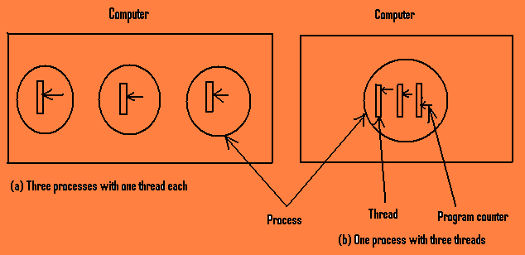
Characteristics of threads:
- Threads are like little mini-processes.
- Each thread runs strictly sequentially, and has its own program counter and stack to keep track of where it is.
- Threads share the CPU, just as processes do: first one thread runs then another does (timesharing). Only on a multiprocessor do they actually run in parallel.
- Threads can create child threads and can block themselves waiting for system calls to complete, just like regular processes. While one thread is blocked another thread in the same process can run, in exactly the same way as the processes do.
- The analogy, thread is to process as process is to machine, holds in many ways.
- All threads have exactly the same address space, which means they share the same global variables. Since every thread can access every virtual address, one thread can read, write, or even completely wipe out another thread’s stack. In addition to sharing the same address space they also share the same set of files, child processes, timers, and signals.

Thread usage
Threads were invented to allow parallelism to be combined with sequential execution and blocking system calls. For example: consider a file server that has to occasionally for the disk. One possible organization of the treads is shown below:
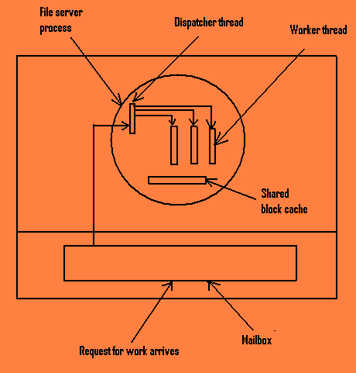
Here one thread, the dispatcher, reads incoming requests for work from the system mailbox. After examining the request, it chooses an idle (i.e. blocked) worker thread and hands it the request. The dispatcher then wakes up the sleeping worker.
When the worker wakes up, it checks to see if the request can be satisfied from the shared block cache, to which all threads have access. If not, it sends a message to the disk to get the needed block (assuming it is a READ), and goes to sleep awaiting completion of the disk operation. The scheduler will now be invoked and another thread will be started, possibly the dispatcher, in order to acquire more work, or possibly another worker that is now ready to run.

Distributed operating system
In a network operating system the resources on each machine on the network are managed by their own operating system. Whereas in a distributed operating system the operating systems on all the individual machines work together to manage the collective network resources.
In the network operating system the users are aware of the existence of multiple computers. They copy the files from one computer to their own. Each machine runs its own local operating system and has its own local user. A distributed operating system appears to the user as a uniprocessor system. Users are not aware of where the programs are being run or where the files are located. It is handled automatically by the distributed operating system.
In a distributed operating system, the O.S allows the applications to run on several processors at the same time. So the scheduling will be more complex. It consists of two or more nodes or workstations. Each node is itself a computer system with its own memory, some communication hardware and it has capability of some function of the operating system.
Advantages of distributed operating system:
➔Resource sharing
➔Reliability
➔Computation speedup.

- feefweefe

